maps look good, just if possible please remove the leading zeros in the map number. for example NM-00042 - PORT WASHINGTON BEACON HILL SEC 3 - 2_25_1915 should be NM-42 - PORT WASHINGTON BEACON HILL SEC 3 - 2_25_1915. The leading zeros will make it difficult to search them

**Leading Zeros ka hm ne pehlay b discuss kia tha k map number ma se remove krni hain. Why is this issue repeating?**

it looks like the deed script is not identifying the deed book and page field correctly. it should be:

N-10-100-518 - Deed - D_10184-1 - P_5 - 05-14-1992 should read N-10-100-518 - Deed - D_10184 - P_5 - 05-14-1992

N-10-100-518 - Deed - D_D-10227-445 - P_5 - 11-23-1992 should read N-10-100-518 - Deed - D_10227 - P_445 - 11-23-1992

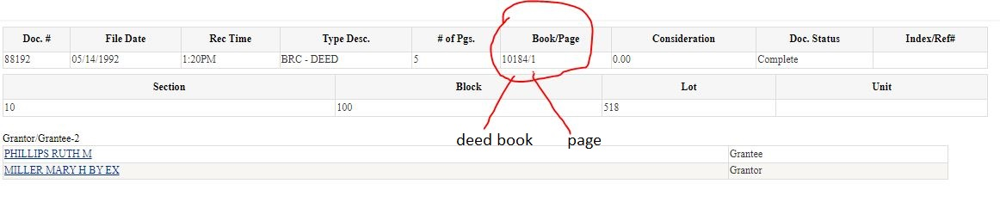

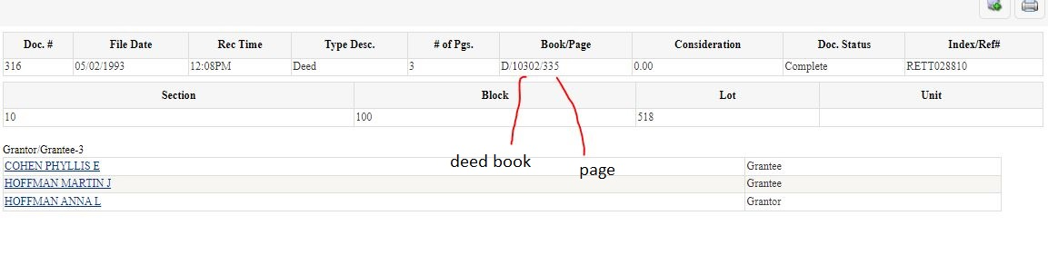

it looks like its a little inconsistent with the way they labeled in the deed book/page field, sometimes there's a D/ sometimes not

sorry I wrote it wrong the first time, it should read: N-10-100-518 - Deed - D_10184-1 - P_5 - 05-14-1992 should read N-10-100-518 - Deed - D_10184 - P_1 - 05-14-1992

N-10-100-518 - Deed - D_D-10227-445 - P_5 - 11-23-1992 should read N-10-100-518 - Deed - D_10227 - P_445 - 11-23-1992